Health and Wellness Professional Resources
---...
-

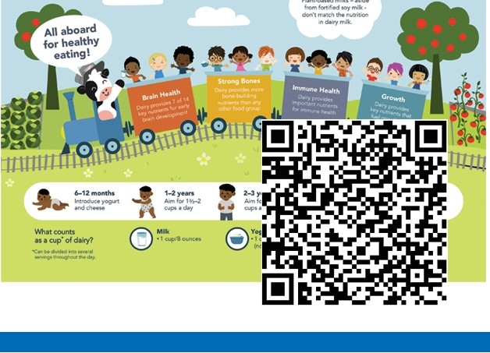
Dairy Every Day is a Healthy Way to Nourisfl Young Kids

Dairy Every Day is a Healthy Way
Dairyfoodshelphealthybrains,boiwsandbodi8$grow

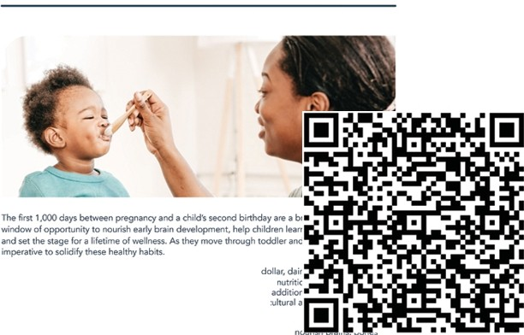
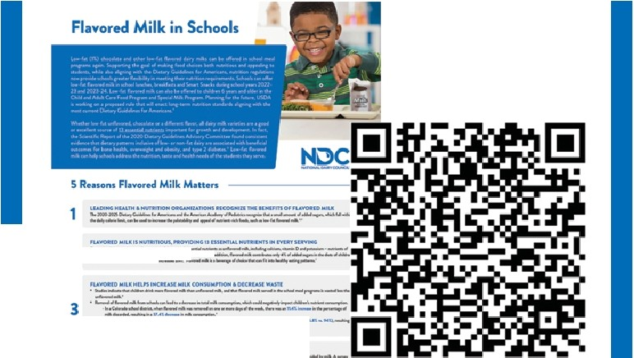
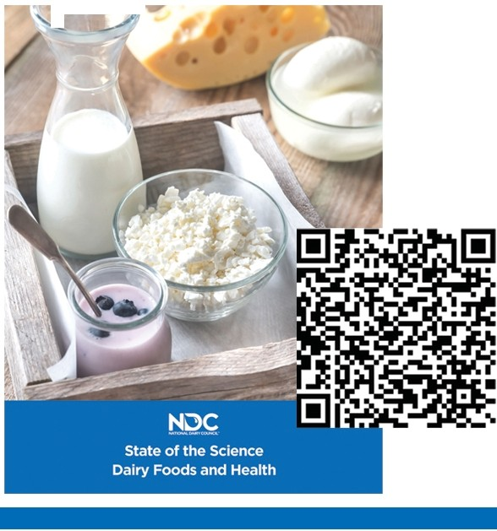
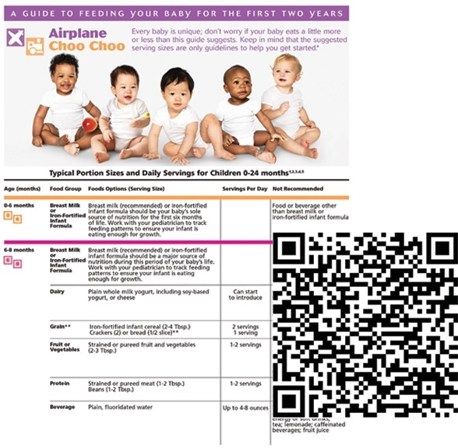
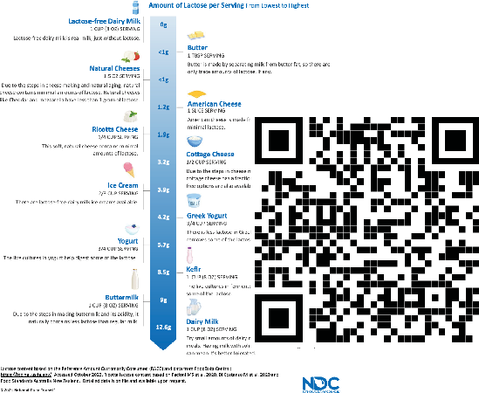
Flavored Milk in Schools
-
--- -
----.., ··-
--
--____...,·-__
--__ M_ .. ·--·-
...---_
·-,...
---- -
·--·
----
..... ..
···
- .. -
-.
---
. -
. -
-
-----
...·-- ...... ..".'
-
---. --
. -
. -
- -
A Fresh Look at Iodine & Prenatal Brain Development
The lmpof't,ilnce of Iodine In Prenatal Brain Development
- -----..
WhJlllodiMlmpo,tant?
- --·

_i1iiiilm1■
,., .._
--
HowMuchlodl­
DoYOIIN"4?
--_- ...
_-
.
- ._
,.-
_, .
-­
....
.., ., .,. ,
------·
State of the Science:
Dairy Food & Health
'
.... ,. ...
Join our DairY Nourishes Networl< to stay
up-to-date on dairy research and resources.
- ..
Physician Resource
Dairy Every Day Is a Healthy Way
to Nourish Brains, Bones, and Bodies

0..-,loo<lo ... bo•-o-l,-,.J.,,. :,,--iOl_otoa.o...,.!,o_,,....
...-..-..t.,..,.,..l.o-od.,_.-,r;q..o..n...d.,d...w...<....r.,ipco l.o,
n.o..\a.i,, - ,,.
::::'°.:-- on'- ,.ioo<l>holi>
A Guide to Feeding your Baby for the First Two Years
Lactose Intolerance: How to Enjoy Dairy Foods with Confidence
Lactose Intolerance: HowtoEnjoyDairvFoodswithConfidence
,_,..,., ,.,IKN-,,.- · -• rn·.e,o1
'· • ...,, .. ...,.,m,w, ,_,

2•••.. -•.-----

,._,.,..u, _
4
s · -

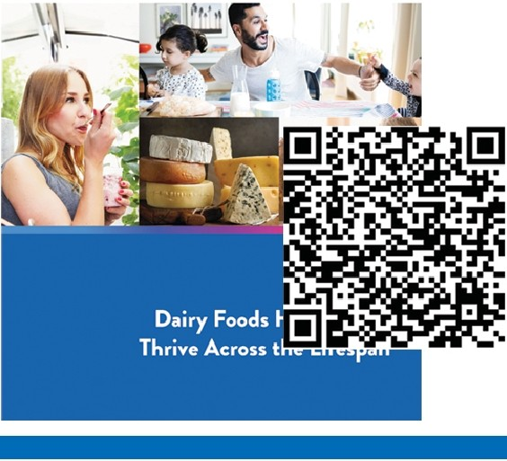
All of these resources can be found on USDairy.com/NationalDairyCouncil
Dairy Foods Help People Thrive Across the Lifespan
t-l C
NNATIONADL DAIRY CCOUNCIL:"
USDairy.com

National Dairy Council's mission is to bring to life thedairy communify's shared vision of a healthy, happy, sustainable world• with science as the fOundatlon. On behalf of America's dairy fanners, National Dairy Council shares science-based lnfonnatlon
0 0
about how nubitious, responsibly produced dairy fOods help nourish people across the lifespan.

©2023 National Dairy Council®

Health Professional Webinars
Dairy Innovations For A Sustainable Future
SHOW ME, DON'T TELL ME.
Dairy Innovations for o
Sustainable Future.
The Dair:)' Matrix: More Than ffie Sum of its Nutrients

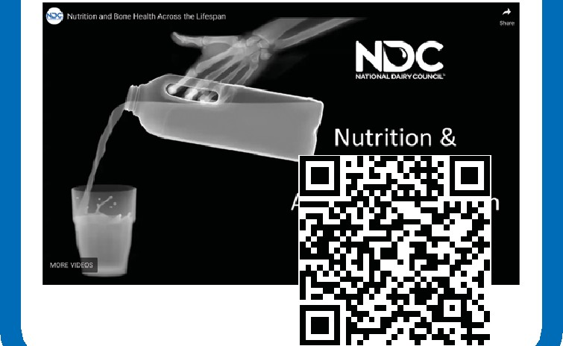
Prenatal Nutrition: Dairy's Building Blocks for Baby's Bram Development
g:.
PRENATAL
NUTRITION:
Dairy's Building Blocks for Baby's Brain Development
Confidently Nourishing Children: What's the Deal with Dairy?

Nutrition And Bone Health Across The Lifespan

Taming the Flame: Dairy & lnflammation
TAMING THE FLAME:  Dairy and  lnRammafion  QC | [!] | I | • | JI
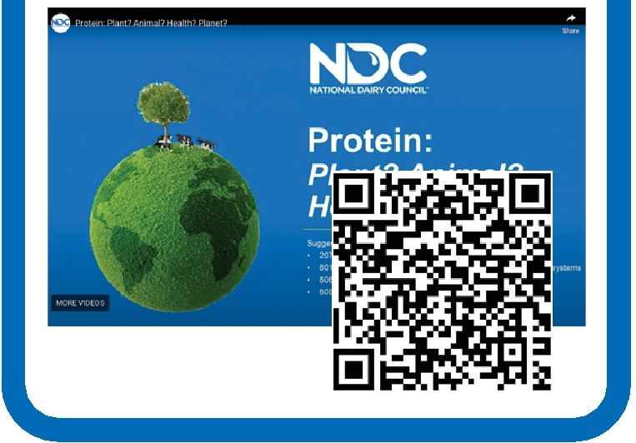
Explorina Protein Sources From Animals And Plants
Want to know more about dairy facts, fiction and FAQs?
Visit National Dairy Council to learn more.

Find your local Dairy Council

